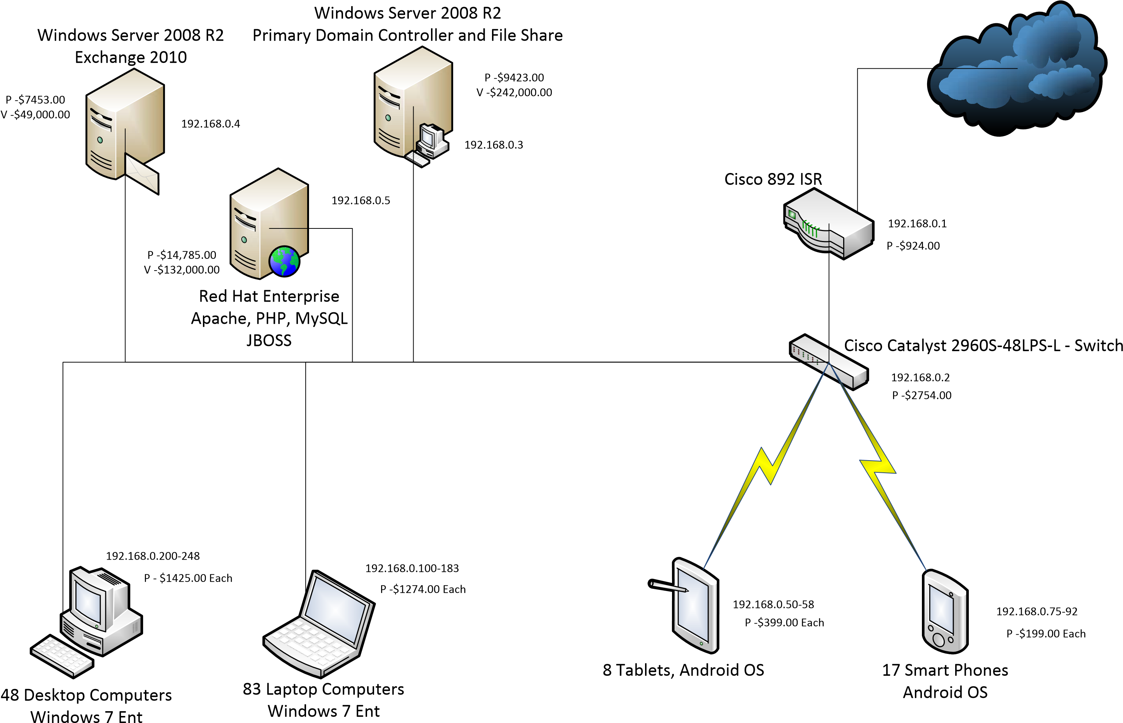

W06A1 – Directions – For this assignment, refer back to your last module’s assignment. Take the above network diagram and identify all single points of failure. Once you find one, describe why it is a SPOF and offer two or three solutions to compensate for this SPOF. In the last section, take one solution from each SPOF and research the cost for implementation.

The switch is an SPOF as we can see that everything runs through the Cisco Catalyst Switch meaning if it fails then nothing can get through. One solution would be to add another switch so that there is another point of entry to the Cisco 892 ISR. There is also delegating level of importance so that some systems will be faster through the switch than others.

There is also the SPOF of the Cisco 892 ISR as if it breaks then the cloud can not be accessed. A way around this would be to create a path around it or get a redundant one in case of failure.

Then there is the SPOF of the link itself as there is only one path that everything is connected and running through meaning if the link is broken then nothing can be accomplished. A means for helping this would be to implement a secondary link that either runs parallel to the first or it can be connected to a switch, and it can link the computers, tablets, and phones together.

From what I could find if we want to get another Switch for the switch SPOF it would cost around $400 depending on where it is found. The support was discontinued in 2020 and updating seems to be a couple thousands. A backup Cisco 892 ISR I found is refurbished for $200-$400. The link SPOF could be accomplished by setting up a link with the backup Cisco 892 ISR purchased from the previous SPOF meaning that cost would be $600 to $800 if we go with cheaper options. The Cisco seems to have moved on to the next series so if we wanted brand new then it would be a couple thousand dollars for new with support.